Registering for Preschool Programs Online:
- Go to community.benderjccgw.org and login to your Bender JCC online account.
  - If you need to create an account, the system will try to match your first name, last name and email address. If you have ever taken classes or had a membership at the JCC we may have you in our system even if you have not yet created an account. If you would like to confirm the information we have on file please contact the registrar using our online registration inquiry: https://www.benderjccgw.org/registrar-inquiry/

- Once you are logged in, click the register online button:

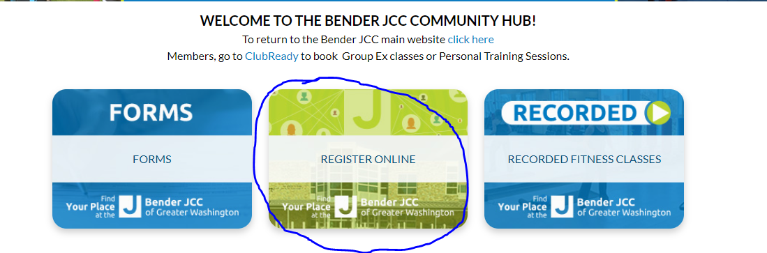

- Entering a keyword of preschool in the search bar will bring up the 2022-23 preschool programs.
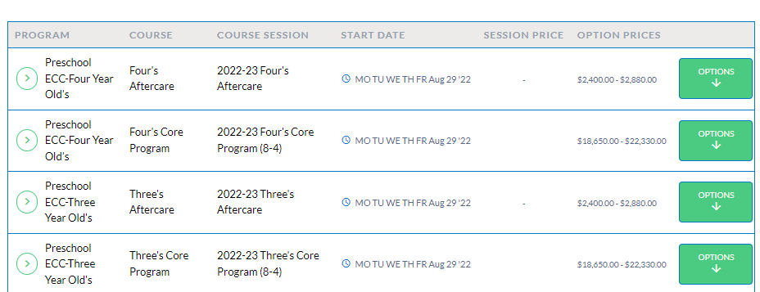

- Select the program that you want to register for by clicking options.
- Select the 10 Month or 12 Month option and click enroll:
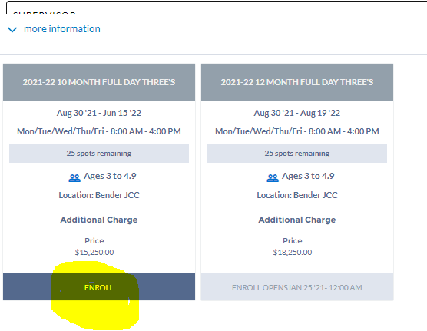

- Select the family member who will be enrolled in the program by clicking on their name and click the blue save button in the bottom right corner. If their name is grayed out, their age in the database may not match the age parameters of the program. (Your child must be the age of the program on 9/1/2022.) Please contact preschool@benderjccgw.org to discuss any age-related registration questions.
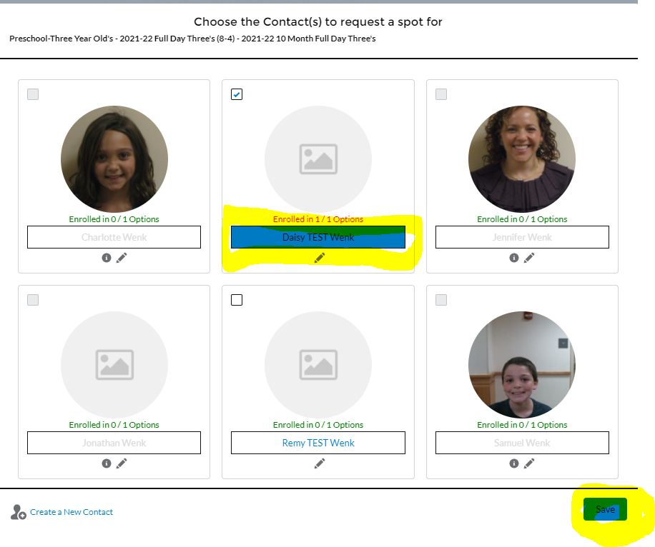

- Please click next in the toolbar at the top of the page:

- Please answer the question and then click next in the toolbar at the top:
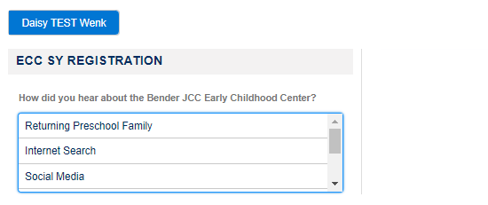

- You will have to sign two waivers during the registration. One is a participation waiver for in-person programs. The second is the terms and conditions for the Bender JCC Early Childhood Center.

- Then click the green Pay button.

- There are two steps required to complete your registration in the program:

  - You must pay the upfront charges: This will be the non-refundable $250 deposit and the $70 ECPC dues for a total of $320 due now.
  - You must save a payment method for the future billing of the program. Your registration cannot be completed without saving a future payment method. We can change it prior to the first billing, but something must be saved in the system at the time of registration.
    - This can be a credit card or an ACH. (A 3% surcharge is applied to credit card payments)
  - Once you have completed both of these steps, press the green done button in the top right corner. The screen will look something like this (the screenshot is for a different program):

